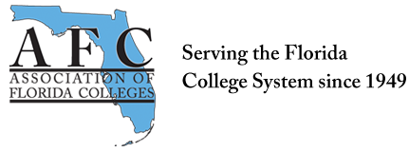
ADMINISTRATION COMMISSION MEETING
February 13, 2018
9:00 a.m.
In attendance: Brenda Rante, Lynne O’Dell, Kerri Hughes, and Mark Thompson via phone.
- Update on Leadership Conference – January 31-February 2, 2018, Tallahassee
- Invoice AFC for the conference registration.
- The AFC leadership manual was shared for the year, and Brenda will email everyone when the manual is available on the AFC site.
- Ribbon cutting took place during the conference for the new building.
- Administrators shared their stories of how they got to where they are and this might be an idea for the Region V joint commission conference.

- Administration Commission By Laws (2014)
- Very old and needs to be updated.
- It should have been reviewed every year and approved by the board.
- Kerri will put the By Laws in a Google Doc for us to review and make suggested changes.
- We will approve the By Laws at the next meeting.

- Treasurer’s Report
- We have money in the commission account only expense is the cost of the state leadership conference. Balance as of 9/15/2017 was $1,642.
- Commission of the Year Requirements
- Would like to win the Commission of the Year award!
- We already have 10 points from Brenda attending conference.

- Website
- Need to update the site everything is from 2014.
- Create a monthly newsletter, and Mark suggested perhaps a weekly post of something that would be beneficial for administrators.
- Mark will work on creating a Facebook page for the Commission and everyone will send picture and brief bio to Mark.
- All changes for the Website needs to be sent to Lucia Fishburne at AFC.

- Administration Commission Makeover!
- Would really like to recruit more members to the Administration Commission Board.
- We need at least one representative from each region, so we need to start thinking about possible people.
- Also, starting thinking about possible fundraising ideas.

Submitted by:

Lynne O’Dell
Chair Elect
Administration Commission

